# First grade – First term

# 1. Sets

## What is a set

* **What is a set?**
  + <https://www.twinkl.com.co/teaching-wiki/set-mathematics>
  + <https://www.mathsisfun.com/sets/sets-introduction.html>

## Suggested activities:

* Create your own set, why is a set?
* Identify 6 sets in your house and explain why they are sets.

## Games:

* <https://wordwall.net/es/resource/78528970/math/sets-of-objects>
* <https://wordwall.net/es/resource/7178922/math/number-sets>
* <https://wordwall.net/es/resource/62246840/shape-sets>

# 2. Greater than, less than, equal to

## Symbols:

* <https://superstarworksheets.com/wp-content/uploads/2023/10/GreaterThanLessThanChart.pdf>

## Worksheets:

* <https://www.superteacherworksheets.com/counting/more-and-fewer_BBAGT.pdf>
* <https://www.superteacherworksheets.com/place-value/greaterless-2digit_TWRBD.pdf>
* <https://www.k5learning.com/free-math-worksheets/first-grade-1/comparing-numbers/more-than-less-than>
* <https://superstarworksheets.com/math-worksheets/comparing-numbers/comparing-numbers-worksheets/>
* <https://www.k5learning.com/free-math-worksheets/first-grade-1/comparing-numbers/compare-numbers-0-100>

## Games:

* <https://www.superteacherworksheets.com/place-value/gt-lt-game2-3-digits_GFDIW.pdf>
* <https://www.starfall.com/h/numbers/greater-less-equals/?sn=math0>
* <https://www.abcya.com/games/comparing_number_values_jr>
* <https://wordwall.net/resource/37870946/greater-than-or-less-than>
* <https://www.education.com/game/less-than-greater-than/>

## Videos:

* <https://www.youtube.com/watch?v=M6Efzu2slaI&list=RDM6Efzu2slaI&start_radio=1>
* <https://www.youtube.com/watch?v=q93lAp6Rh5g&list=RDq93lAp6Rh5g&start_radio=1>

# 3. Word Problems

## Worksheets:

* <https://www.superteacherworksheets.com/addition/adding-2digit-noregroup_TTWTN.pdf>
* <https://www.superteacherworksheets.com/addition/adding-columns3_TTZDN.pdf>
* <https://www.k5learning.com/free-math-worksheets/first-grade-1/word-problems/adding-single-digit-numbers>
* <https://www.k5learning.com/free-math-worksheets/first-grade-1/word-problems/addition-sums-50>
* <https://www.k5learning.com/free-math-worksheets/first-grade-1/word-problems/addition-3-addends>
* <https://www.superteacherworksheets.com/daily-word-problems-a.html>
* <https://www.k5learning.com/free-math-worksheets/first-grade-1/word-problems/subtraction>
* <https://www.k5learning.com/free-math-worksheets/first-grade-1/word-problems/subtraction-2-digits>

## Game:

* Create your own problem and share with your family
* <https://wordwall.net/es/resource/51869249/math/math-word-problems-for-first-grade>
* <https://www.iknowit.com/lessons/a-addition-subtraction-word-problems-within-20.html>

## Videos:

* <https://www.youtube.com/watch?v=C229LUk380Q>
* <https://www.youtube.com/watch?v=s3jP0vnFSxE>

## UPAC:

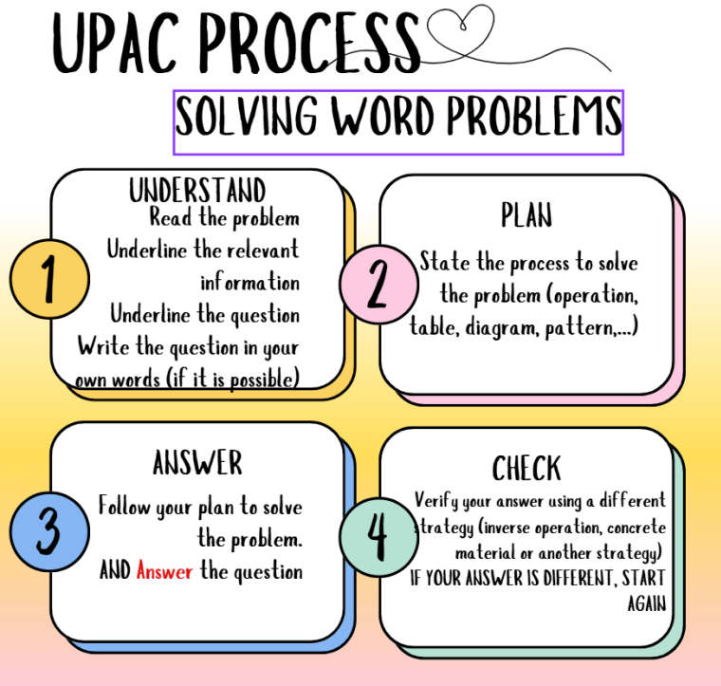

You can use this template to solve problems:

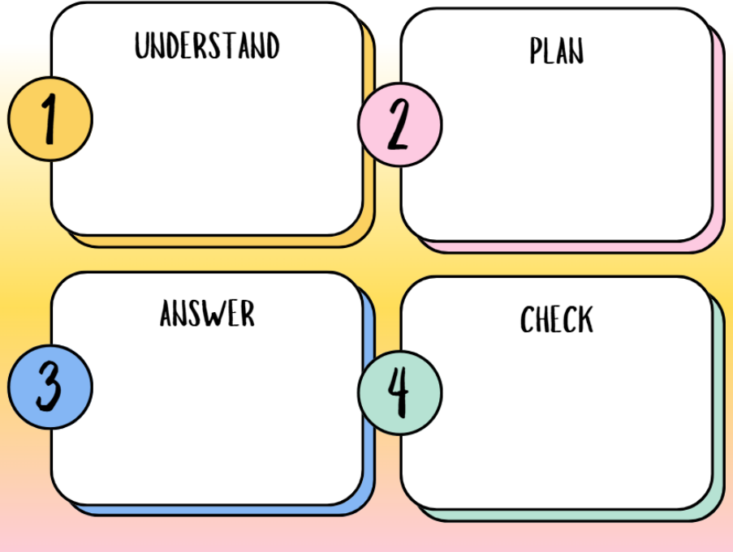

# 4. Patterns / Patrones

## Worksheets:

* <https://www.mathworksheets4kids.com/worksheets/1st-grade/patterns/repeating-circle-1.pdf>
* <https://www.mathworksheets4kids.com/patterns/repeating-cut-paste1.pdf>
* <https://www.mathworksheets4kids.com/patterns/growing-type1-1.pdf>
* <https://www.mathworksheets4kids.com/patterns/repeating-growing-mixed1.pdf>
* <https://www.mathworksheets4kids.com/patterns/size-circle1.pdf>
* <https://www.mathworksheets4kids.com/patterns/color-easy1.pdf>

## Video:

* <https://www.youtube.com/watch?v=CzFLDtvN_Xk>
* <https://www.youtube.com/watch?v=Js45cR_7wFE>

## Games:

* <https://www.abcya.com/games/shape_patterns>
* <https://wordwall.net/resource/34012902/patterns>
* <https://wordwall.net/resource/35314613/patterns>
* <https://wordwall.net/resource/27288737/patterns-game>
* <https://wordwall.net/resource/29534647/colour-patterns>
* <https://wordwall.net/resource/39037001/numberblocks-patterns>

# 5. Tessellations

## What is?

<https://www.mathsisfun.com/geometry/tessellation.html>

## Worksheets:

* <https://www.k5learning.com/worksheets/math/grade-4-geometry-tessellations-a.pdf>
* <https://www.k5learning.com/worksheets/math/grade-4-geometry-tessellations-b.pdf>

## Video:

<https://www.youtube.com/watch?v=7GiKeeWSf4s>

[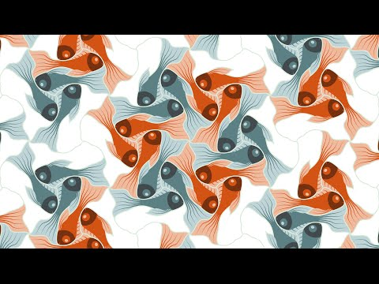](https://www.youtube.com/watch?v=7GiKeeWSf4s)

### **6. How do you write numbers?**

[https://www.123homeschool4me.com/free-number-works](https://www.123homeschool4me.com/free-number-worksheets_18/?utm=)